**WEEK 12**

**AIM:** To develop Swing application which uses JList, JTree, JTable

**THEORY**: Swing is a set of classes that provides more powerful and flexible components than are possible with the AWT. In addition to the familiar components, such as buttons, check boxes, and labels, Swing supplies several exciting additions, including tabbed panes, scroll panes, trees, and tables. Even familiar components such as buttons have more capabilities in Swing. For example, a button may have both an image and a text string associated with it. Also, the image can be changed as the state of the button changes. Unlike AWT components, Swing components are not implemented by platform-specific code. Instead, they are written entirely in Java and, therefore, are platform-independent.

**ALGORITHM: JList**

STEP1: START

STEP2: Create the List of elements using DefaultListModel.

STEP3: Add above created list to JList.

STEP4: Create a JFrame and add JList to the JFrame.

STEP5: Set the JFrame size and set setVisible(true) to make the JList visible.

STEP6: END

**SOURCE CODE: JList**

import javax.swing.*;

public class ListExmp

{

ListExmp(){

JFrame f= new JFrame();

DefaultListModel d = new DefaultListModel<>();

d.addElement("Item1");

d.addElement("Item2");

d.addElement("Item3");

d.addElement("Item4");

JList list = new JList(d);

list.setBounds(100,100, 75,75);

f.add(list);

f.setSize(400,400);

f.setLayout(null);

f.setVisible(true);

f.setDefaultCloseOperation(JFrame.EXIT_ON_CLOSE);

}

public static void main(String args[])

{

new ListExmp();

}

}

**OUTPUT: JList**

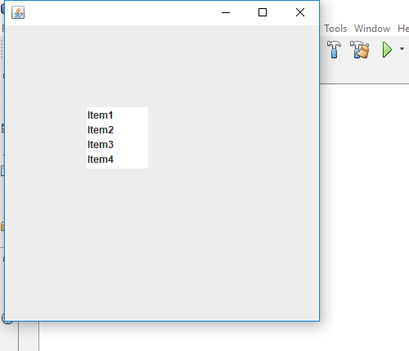

**ALGORITHM: JTree**

STEP1: START

STEP2: Create a Panel and set panel Layout.

STEP3: Create JTree to the Panel.

STEP4: set the properties of the JTree class

STEP5: END

**SOURCE CODE: JTree**

import javax.swing.*;

import javax.swing.tree.DefaultMutableTreeNode;

public class TreeEx

{

JFrame f;

TreeEx(){

f=new JFrame();

DefaultMutableTreeNode style=new DefaultMutableTreeNode("Style");

DefaultMutableTreeNode color=new DefaultMutableTreeNode("color");

DefaultMutableTreeNode font=new DefaultMutableTreeNode("font");

style.add(color);

style.add(font);

DefaultMutableTreeNode red=new DefaultMutableTreeNode("red");

DefaultMutableTreeNode blue=new DefaultMutableTreeNode("blue");

DefaultMutableTreeNode green=new DefaultMutableTreeNode("green");

color.add(red);

color.add(blue);

color.add(green);

JTree jt=new JTree(style);

f.add(jt);

f.setSize(250,250);

f.setVisible(true);

f.setDefaultCloseOperation(JFrame.EXIT_ON_CLOSE);

}

public static void main(String[] args) {

new TreeEx();

}

}

**OUTPUT: JTree**

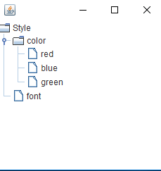

**ALGORITHM: JTable**

STEP1: START

STEP2: Create a Panel and set panel Layout.

STEP3: Add JTable to the Panel.

STEP4: Set the JTable rows and columns .

STEP5: Load the data into the JTable

STEP6: END

**SOURCE CODE: JTable**

import javax.swing.*;

public class TableEx

{

JFrame f;

TableEx()

{

f=new JFrame();

String data[][]={ {"501","ravi","50000"},

{"502","raju","70000"},

{"503","ramu","90000"}};

String column[]={"ID","NAME","SALARY"};

JTable jt=new JTable(data,column);

JScrollPane sp=new JScrollPane(jt);

f.add(sp);

f.setSize(300,400);

f.setVisible(true);

f.setDefaultCloseOperation(JFrame.EXIT_ON_CLOSE);

}

public static void main(String[] args)

{

new TableEx();

}

}

**OUTPUT: JTable**

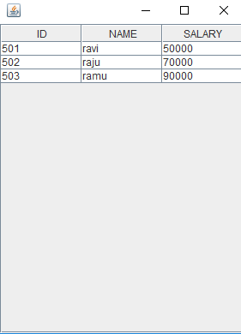

**VIVA VOCE:**

1. What is the purpose of Swings in Java?

Java Swing is a part of Java Foundation Classes (JFC) that is used to create window-based applications. It is built on the top of AWT (Abstract Windowing Toolkit) API and entirely written in java. Unlike AWT, Java Swing provides platform-independent and lightweight components. The javax.swing package provides classes for java swing API such as JButton, JTextField, JTextArea, JRadioButton, JCheckbox, JMenu, JColorChooser etc.

2. What is the purpose of JList class?

The object of JList class represents a list of text items. The list of text items can be set up so that the user can choose either one item or multiple items. It inherits JComponent class.

1. What is the purpose of JTree class?

The JTree class is used to display the tree structured data or hierarchical data. JTree is a complex component. It has a 'root node' at the top most which is a parent for all nodes in the tree.

1. What is the purpose of JTable class?

The JTable class is a part of Java Swing Package and is generally used to display or edit two-dimensional data that is having both rows and columns. It is similar to a spreadsheet. This arranges data in a tabular form.

1. Differentiate between applet and swing.

Applet uses AWT Layouts like flowlayout. Swing have some Thread rules. Applet doesn't have any rule. To execute Swing no need any browser By which we can create stand alone application But Here we have to add container and maintain all action control with in frame container.